Learning Journal Unit 4

**Part 1**

Section 6.2 of your textbook describes **incremental development**. Do the exercise at the end of that section:

As an exercise, use incremental development to write a function called hypotenuse that returns the length of the hypotenuse of a right triangle given the lengths of the other two legs as arguments. Record each stage of the development process as you go. (Downey, 2015)

After the final stage of development, print the output of hypotenuse(3, 4) and two other calls to hypotenuse with different arguments.

Include all of the following in your Learning Journal:

* An explanation of each stage of development, including code and any test input and output.
* The output of hypotenuse(3,4).
* The output of two additional calls to hypotenuse with different arguments.

SOLUTION:

def hypotenuse(leg1,leg2): #our function has 2 arguments for first leg and second leg respectively

return (leg1**2+leg2**2)**(1/2) #according to Pythagorean theorem, the hypotenuse is equal to the square root of the sum of the squares of the legs

print("Test number 1, triangle with legs 3 and 4, hypotenuse is:",hypotenuse(3,4))#prints the call for triangle with legs 3 and for

print("Expected 5")#expected result

print("Test number 1, triangle with legs 12 and 5, hypotenuse is:",hypotenuse(12,5))#same for 12 and 5

print("Expected 13")

print("Test number 1, triangle with legs 20 and 21, hypotenuse is:",hypotenuse(20,21))#20 and 29

print("Expected 29")

RESULT->

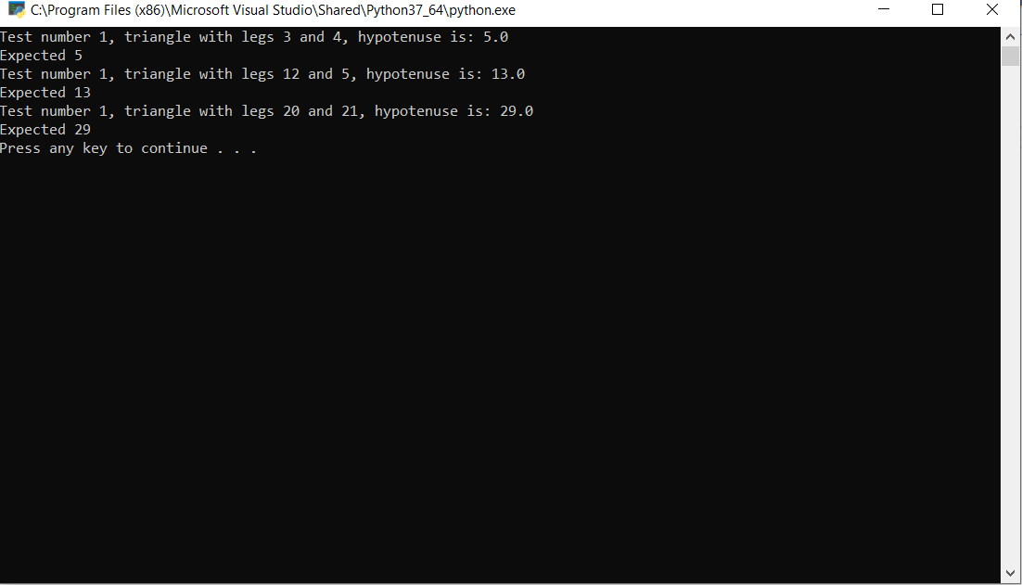

**Part 2**

Invent **your own function** that does some useful computation of your choosing. **Do not copy the function from somewhere else**. Use incremental development, and record each stage of the development process as you go. Finally, print output that demonstrates that the function works as you intended.

Include all of the following in your Learning Journal:

* An explanation of each stage of development, including code and any test input and output.
* The output of three calls to your function with different arguments.

SOLUTION:

# WE ARE USING Python 3.9.5

import math #WE NEED TO IMPORT FIRST Library for displaying pi

def get_cylinder_volume(r, h): #HERE IS THE Function declaration

r = int(r) #HERE WE NEEDED TO Change the format of the

h = int(h) # VRAIABLES FROM STR TO INT TYPE

if r > 0 and h > 0: #AT THIS STEP WE ARE Сhecking the input of valid data

V = h*r*math.pi #AND THERE WE ARE Сalculating the volume of the cylinder

print('Volume of cylinder: ', round(V, 2))#FINALLY HERE IS THE FINAL Displaying result

else:

#IF THE ENTERED NUMBER IS NOT CORRECT -> Message in case of incorrect input

print('Invalid data was entered, please try again!')

#MESSAGE TO Enter data

r, h = input('Enter a space-separated value for the radius and height: ').split()

#WHERE WE CALLED OUR Function call

get_cylinder_volume(r, h)

#NB: THEN THERE The function can be checked with any positive numbers

RESULT->

